**DAILY ONLINE ACTIVITIES SUMMARY**

|  |  |  |  |  |  |  |  |  |
| --- | --- | --- | --- | --- | --- | --- | --- | --- |
| **Date:** | **20-05-2020** | | | | | **Name:** | **JAIDITHYA** | |
| **Sem & Sec** | **6th B section** | | | | | **USN:** | **4AL17CS118** | |
| **Online Test Summary** | | | | | | | | |
| **Subject** | | **SSCD** | | | | | | |
| **Max. Marks** | | **30** | | **Score** | | | **23** | |
| **Certification Course Summary** | | | | | | | | |
| **Course** | **IoT Blockchain Network for a Supply Chain** | | | | | | | |
| **Certificate Provider** | | | **Cognitive class** | | **Duration** | | | **3hrs** |
| **Coding Challenges** | | | | | | | | |
| **Problem Statement:** Program 1- Write a C Program to Reverse a Linked List in groups of given size  Program 2- Python Program to Exchange the Values of Two Numbers using ^ (exclusive or operator) | | | | | | | | |
| **Status: solved** | | | | | | | | |
| **Uploaded the report in Github** | | | | | **Yes** | | | |
| **If yes Repository name** | | | | | **Daily status-20th** | | | |
| **Uploaded the report in slack** | | | | | **yes** | | | |

Online test report assessment screenshot

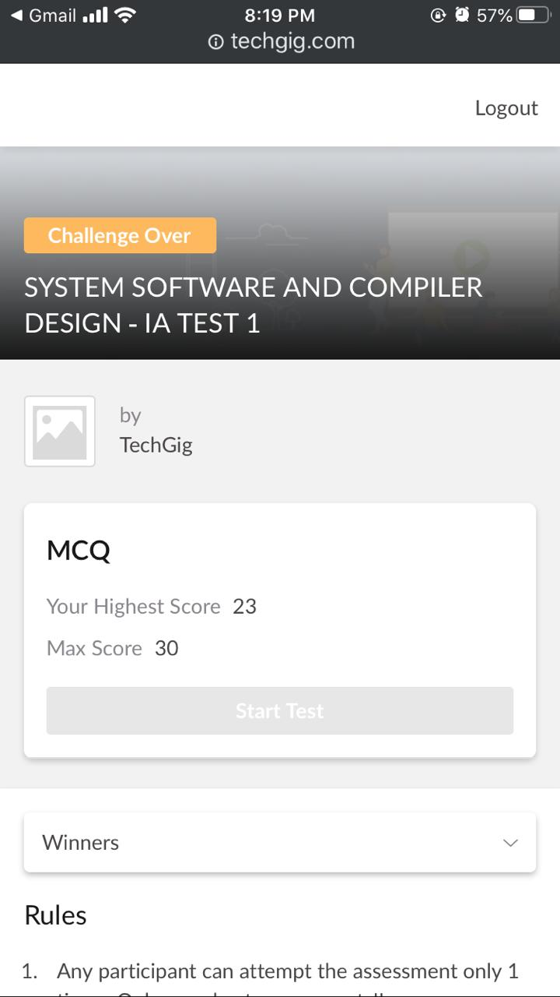

Certification course details- **Build an IoT Blockchain Network for a Supply Chain**

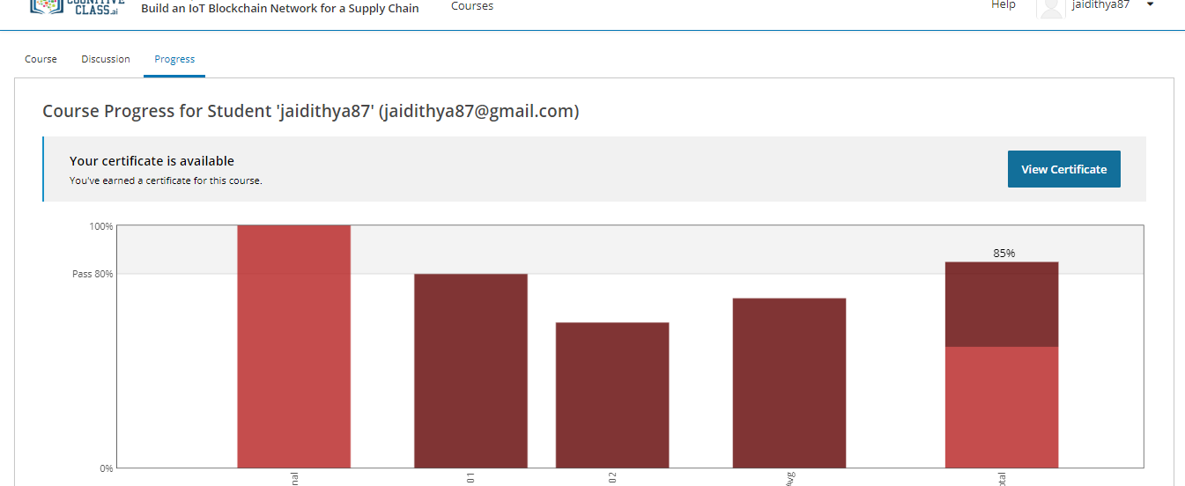

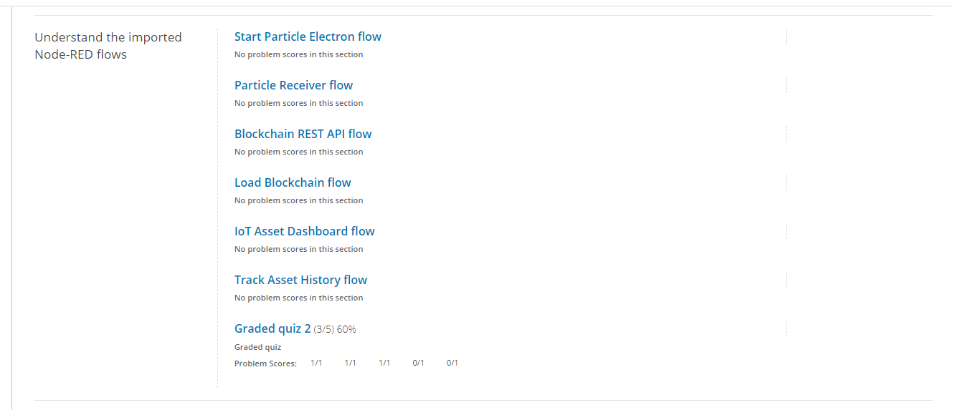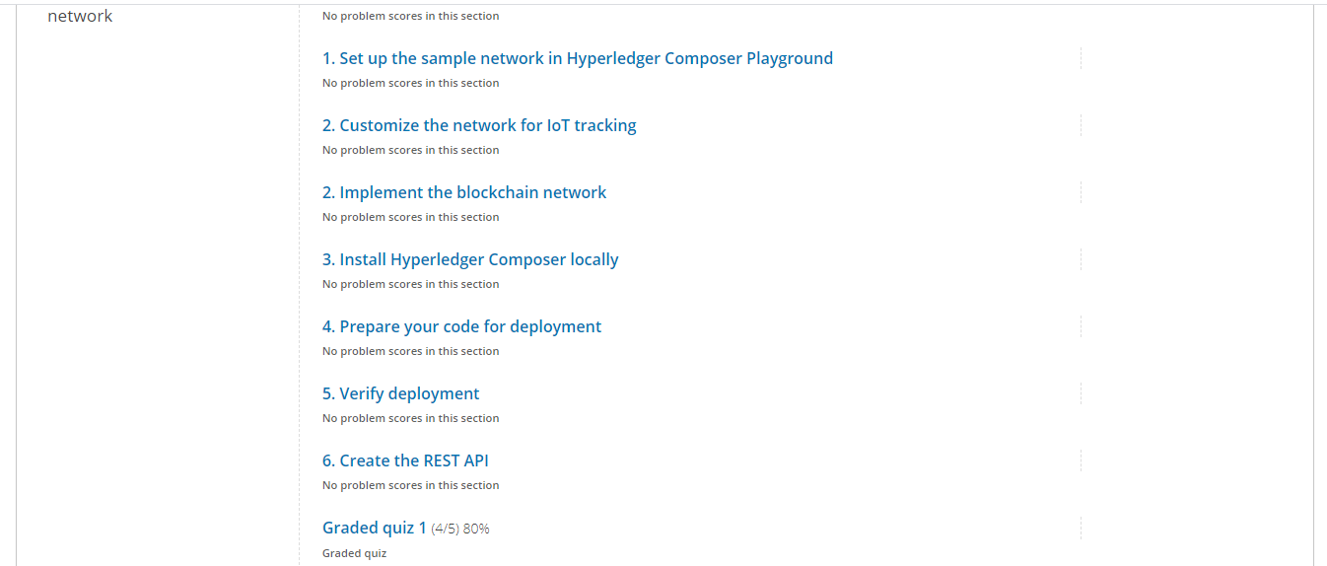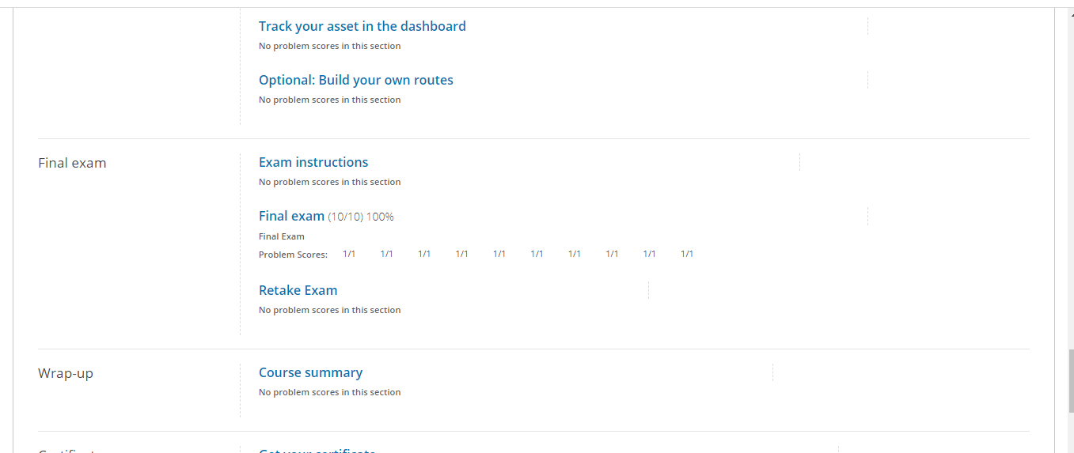

Coding Challenges Details

Program 1- Write a C Program to Reverse a Linked List in groups of given size

Program 2- Python Program to Exchange the Values of Two Numbers using ^ (exclusive or operator)

